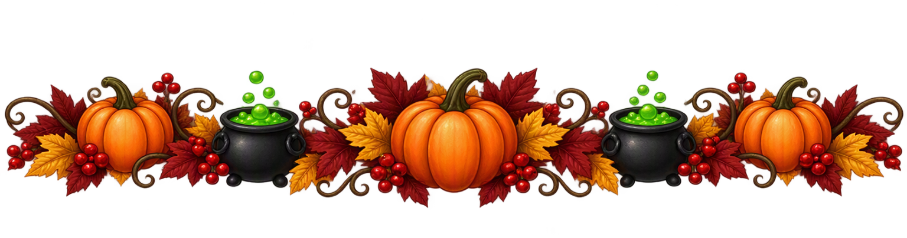

Flamingo Lakes Fall Festival
🍂Saturday October 24, 2026🍂
Categories are:
Ghoulish Chili
Spooky Appetizers
Jack-O-Lanterns
Winners in all 3 categories win a $25.00 Amazon gift card (aka bragging rights)
You must have your entries checked by 5:00 pm.
Judging starts @ 5:00 for Spooky Appetizers / 5:30 for Ghoulish Chili / Jack-O-Lanterns @ dusk for lighting (you must bring your own pumpkin pre-carved and lighting)
All entries will be given a number.
In case we have a tie; naming of your entry, example: “ghost chili”, or your display (caldron crock pots) of your entries will be judged.

IF YOU WANT TO BE A JUDGE IN CHILI TASTING; YOU MUST LIVE HERE AND NOT HAVE AN ENTRY IN THE CHILI CATEGORY
WE NEED 5 VOLENTEERS: To sign up to be a judge Call or Text 936-727-4362

All other categories will be judged by everyone who attends. We will have voting jars, and the number of your choice will go into the selected category.
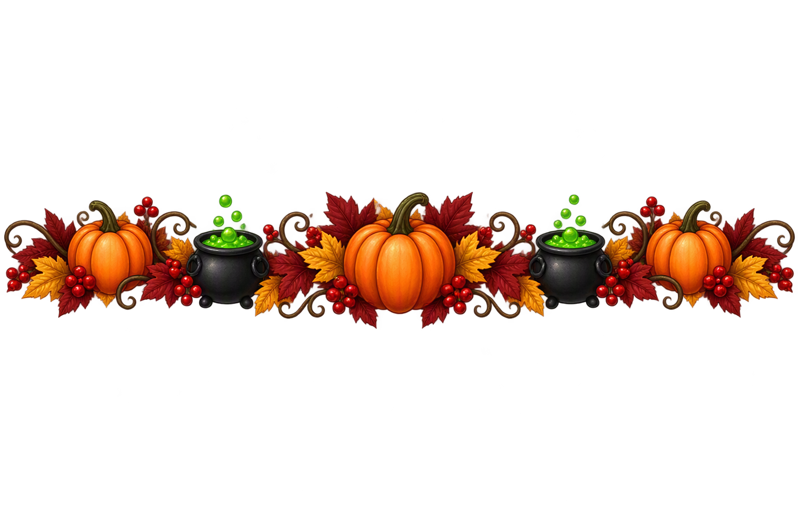
Be sure to come early for the Spooky Appetizers vote / before they disappear!
If you do not like chili the Flamingo Lake board will provide wieners on a stick you can roast yourself at the bonfire down by the lake and smores are for toasting!

Taste. Vote. Celebrate.

